React Js
Features:-
  - OpenSource
  - FrontEnd JS Library
  - Creating Component based User Interface
  - Developed by META
  - SinglePage Application(Website may contain multiple pages but they doesn’t reload )
  - Mobile Friendly Application
  - Less Code
  - Can create Interactive User Interface
  - Reusability(to create reusable UI Components and manage the state of those components)
  - Scalability(can create large real time application)
  - websites powered by React
Facebook, popular social media application
Instagram, popular photo sharing application
Netflix, popular media streaming application
Code Academy, popular online training application
Reddit, popular content sharing application
Note:
Reactcollection of components as functional components(class components also)
Imperative vs Declarative Programming:-
Imperative
<script type="text/javascript">
const app = document.getElementById('app');
const header = document.createElement('h1');
const headerContent = document.createTextNode('Develop. Preview. Ship. 🚀');
header.appendChild(headerContent);
app.appendChild(header);
</script>

Declarative
<script type="text/jsx">
const app = document.getElementById("app")
ReactDOM.render(<h1>Develop. Preview. Ship. 🚀</h1>, app)
</script>

Note:
Imperative programming is like giving a chef step-by-step instructions on how to make a pizza. Declarative programming is like ordering a pizza without being concerned about the steps it takes to make the pizza.

Instalation:-
Download & Install NODE from nodejs.org website
Install VS Code
go to extensiones7 rACTES7+REACT/REDUX/REACT-NATIVE...
Note:
- npm: Node Package Manager
- npx: Node Package Execute(npm package runner)
- To execute any JavaScript package available on the NPM registry without even install it

DOM vs VDOM:-
DOM:Document Object Model
- HTMl document as a tree structure where in each node is an object representing a part of the document
- The DOM represents a document with a logical tree
- The browser reads the HTML and constructs the Document Object Model (DOM).

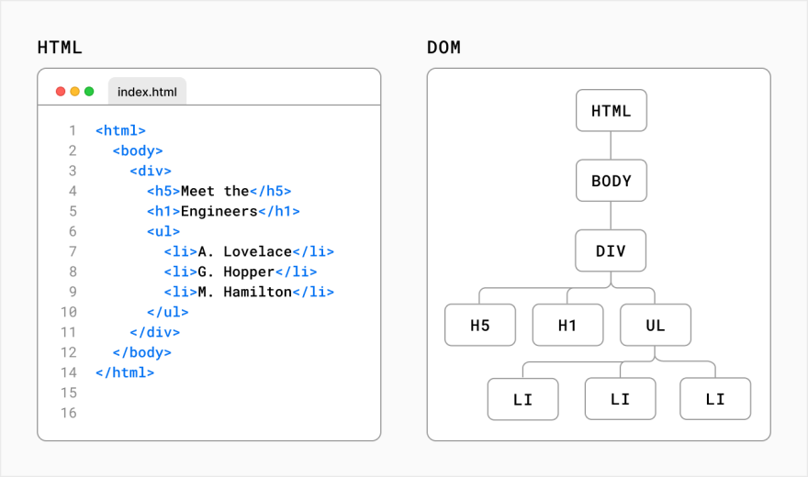
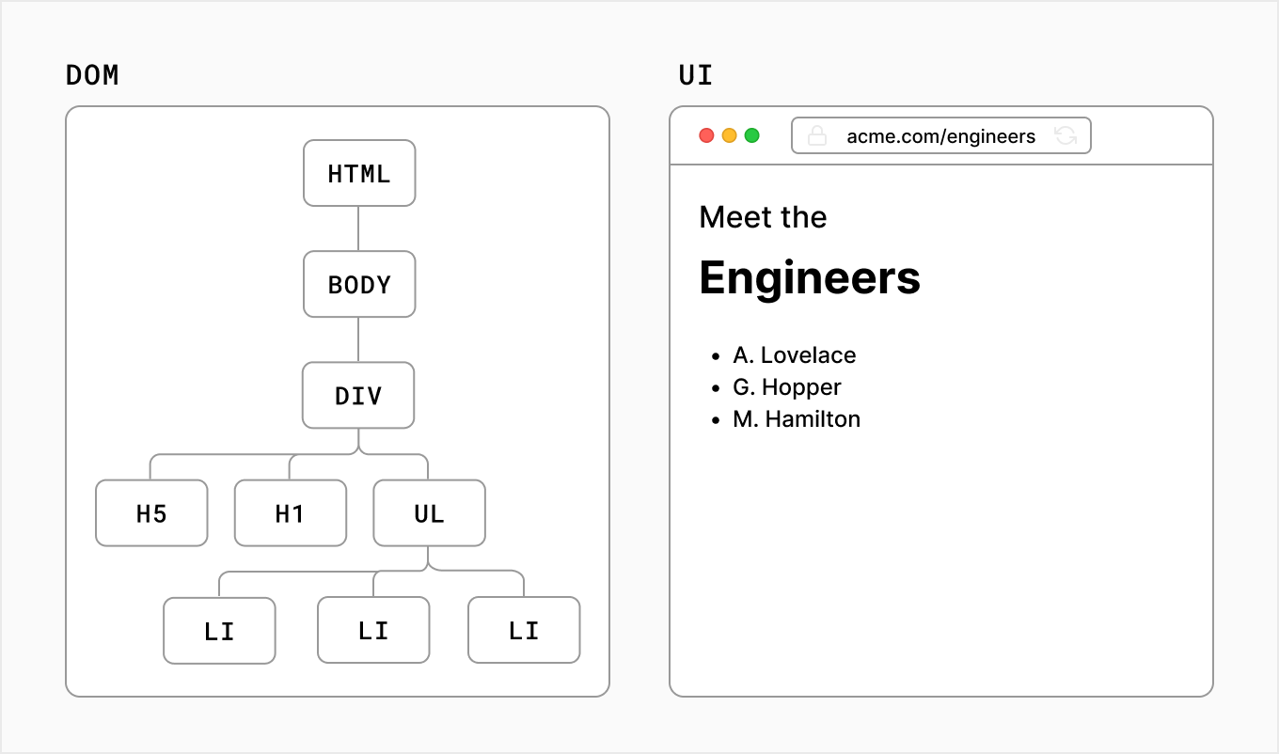
VDOM:Virtal DOM
- React generates a virtual DOM, which is an in-memory data-structure cache. Only the final DOM updates have been updated in the browser's DOM.
- A programming concept where an ideal or “virtual” representation of a UI kept in memory and synced with the “real” DOM by a library such as ReactDOM. This process is called Reconcilation
Eg:
Place <div id=”one”>….</div> into App.js after header tagrunvies sourcewe cant see <ul>tag
Note:
index.js
- const root=ReactDOM.createReact(….root”)
Injecting our JSX inside root element using react dom

Create React Project:-
- In vscodeopen foldercreate foldertype project name(MyReactApp)select folder
- Viewterminal
npm create vite@latest myreactapp
- name must be in lower case
choose react (use downarrow key and press enter)
choose javascript
cd myreactapp
npm install
- to create react app with supported file system automattically
Note:
If cant execute commandopen powershellSet-ExecutionPolicy RemoteSigned -Scope CurrentUser

To run:-
npm run dev
ctrl+c - to stop running

Components:-
- similar to pure javascript functions
- splits the user interface into independent parts, each of which can be processed separately
- to simplify the code by separating the functionality into reusable independent code
- Components can be used as functions and as classes.
- Components also have a state, and props
Functional Components:-
  - each component must be in seperate file
  - App.jsx - root compnent
  - all component name must be in CamelCase

To insert function:
type rfce to insert function  import React from 'react'  function ComponentName() {  return (  <div> ComponentName </div>  )  }  export default ComponentName | type rafce --> to insert arrow function  import React from 'react'  const ComponentName = () => {  return (  <div> ComponentName </div>  )  }  export default ComponentName

Note:Create JSX file(Component) and type rfceenter to auto generate code

JSX: Javascript Expressions:-
JSX is a syntax extension for JavaScript that allows to describe UI in a familiar HTML-like syntax.

Note:
Browsers don’t understand JSX out of the box, so need a JavaScript compiler, such as a Babel, to transform your JSX code into regular JavaScript.

App.js file:
function App{
return(
{JSX code}(known as declartive programming)
)
}
Note:
JSX must have one parent element
return(
<div> any tag or <></> (fragment)
-code-
</div> )
React JS Disadvantages:-
1.code is written in JSX( HTML and CSS are part of the javascript code) ,other frameworks keep HTML
separate from the javascript code.
2.huge file size.
Note:
Elements Must be Closed
<input type="text"/>
Use attribute className instead of class in JSX:
<h1 className="myclass">Hello World</h1>

Eg: Simple html tags
App.js:
function App(){
return (
<div>
<h1>Hello ReactJs!</h1>
</div>
);
}
export default App;

Eg: jsx code
App.js:
function App(){
let a=10
return (
<div>
<h1>Hello ReactJs!</h1> html code
<br/>
{a} jsx code
</div>
);
}
export default App;

Eg: jsx code
App.js:
function App(){
let a=10
let b=20
<h1>Hello ReactJs!</h1>
return (
<div>
{b}
<br/>
{a}
</div>
);
}
export default App;

Eg:
App.js:
function App(){
let a=10
function show(){
alert(“Hello”)
}
show()
return(
<div>
<h1>Hello ReactJs!</h1>
<br/>
{a}
</div>
);
}
export default App;

Eg:
App.js:
function App(){
let a=10
function show(){
alert("Hello")
}
return(
<div>
<h1>Hello ReactJs!</h1>
<br/>
{a}
{show()}
</div>
);
}
export default App;

Eg: functionalcomponent
Right click on src folderfileMyButton.jsx
MyButton.jsx
function MyButton(){
return(
<button>I'm a button</button>
);
}
Export default MyButton;

App.js:
function App(){
let a=10
function show(){
alert(“Hello”)
}
show()
return(
<div>
<h1>Hello ReactJs!</h1>
<br/>
{a}
<MyButton/>
</div>
);
}
export default App;

Assessment:
Create component named OrderedList,UnOrderedList,DefinitionList with suitable content and include those into App component

Function call in React
import React from 'react'
function Sample3() {
function show()
{
alert("Welcome")
}
function display()
{
console.log("Hello")
}
function put()
{
console.log("put")
}
show()
function add(x,y)
{
console.log(x+y)
}
return (
<div>
{display()}
call put function whenever button clicked
<button onClick={put}>PUT</button><br/>

call put function only when page load
<button onClick={put()}>PUT</button><br/>

call add function only when page load
<button onClick={add(3,4)}>ADD</button><br/>

call add function whenever button clicked(use arrow function)
<button onClick={()=>add(3,4)}>ADD</button><br/>
a</div>
)
}
export default Sample3

Eg: JS objects
App.js
const user = {
name: 'Hedy Lamarr',
imageUrl: 'https://i.imgur.com/yXOvdOSs.jpg',
imageSize: 90,
};

<h1>{user.name}</h1>
<img src={user.imageUrl} alt={'Photo of ' + user.name} width={user.imageSize} height={user.imageSize}/>

Assessment:
  - Create student object with sno,sname,course,duration attributes and display these line by line
  - |||^{ly} for books,account,course

Conditional rendering
Eg: using if
const x =5
let text
if(x <10){
text ="Hello"
}
<h1>{text}</h1>

Eg:using && (logical and) (shorter code)
let x =5
<h1>{ x<10 && "Hello"}</h1>

Eg: using if else
let x =5
let y
if(x<10){
y="Hello"
}
else{
y="Goodbye"
}
<h1>{y}</h1>

Eg: using ?: (conditional op) (shorter code)
let x =5;
<h1>{(x)<10?"Hello":"Goodbye"}</h1>
Eg:
let content;
let isLoggedIn=true;
if(isLoggedIn){
content = <AdminPanel/>;
}else{
content = <LoginForm/>;
}
{content}

Eg:
let content;
let isLoggedIn=true;
{isLoggedIn ? (<AdminPanel/>) : (<LoginForm/>)}

Note:
don’t need the else branch {isLoggedIn &&<AdminPanel />}

Rendering lists
Eg:Using for loop
const numbers = [1, 2, 3, 4, 5];
let i;
for(i=0;i<numbers.length;i++)
console.log(numbers[i])

Eg:Using map function
const numbers = [1, 2, 3, 4, 5];
numbers.map((x)=>console.log(x) )

Eg:
const numbers = [1, 2, 3, 4, 5];
<ul>
{numbers.map((number) => (
<li key={number}>{number}</li>
))}
</ul>

Eg:
Header.js
<div>Header</div>
Content.js
function show()
{
const names=["Grow","Earn","Give"];
const nos=Math.floor(Math.random()*3);
return names[nos];
}
<p>Let's {show()} Money!</p>
Footer.js
const Year=new Date();
<footer>Copyright &copy; {year.getFullYear()} </footer>
App.js
import Header from ".Header";
import Content from ".Content";

<div><Header/></div>
<div><Content/></div>
<div><Footer/></div>
Note: import statements are automattically inserted when ues autocomplete option while type component name

Eg:method:1
const products = [
{ title: 'Cabbage', isFruit: false, id: 1 },
{ title: 'Garlic', isFruit: false, id: 2 },
{ title: 'Apple', isFruit: true, id: 3 },
];

const listItems = products.map(product =>
<li key={product.id} style={{color: product.isFruit ? 'magenta' : 'darkgreen'}}>
{product.title}
</li>
);

<ul>{listItems}</ul>

Eg:method:2
const products = [
{ title: 'Cabbage', isFruit: false, id: 1 },
{ title: 'Garlic', isFruit: false, id: 2 },
{ title: 'Apple', isFruit: true, id: 3 },
];

<ul>
{products.map((x)=>
<li style={x.isFruit ? {color:'magenta'}:{color:'green'}}>
{x.title}
</li>
)
}
</ul>

Note: https://nextjs.org/learn/foundations/from-javascript-to-react

Component with CSS Styles:-
Eg: Method1
Header.js
<Header style={{backgroundColor:'blue',color:'white'}}>
<h1>To Do List</h1>
</Header>

Note:{{}} outer {} is for JSX and inner{} is for css object
Eg:Method2
const headerStyle={backgroundColor:'blue',color:'white'}
'<Header style={headerStyle}>
Eg:Method3
<Header class=”MyHeader”>…..
header.css:
.MyHeader
{
backgroundColor:'blue';
color:'white';
}
Eg:
var myStyle = {
fontSize: 80,
fontFamily: 'Courier',
color: '#003300'
}
<h1 style = {myStyle}>www.javatpoint.com</h1>
Note:
Invalid jsx cods:
{object} eg:{a:1,b:2}
{boolean} eg:{1===1}
Object and boolean are not react child
Jsx comment: {/*……*/} shift+alt+a

Class Components:
Class Show extends React.Component{
render(){
return <h1>Hello,(this.props.name}</h1>;
}
}

Function Types
Type 1: function with name  function show(){  return 10;  }  let x=show();  console.log(x); | Type 1: function with name  a=[1,2,3,4,5]  a.map(function show(b)  { console.log(b) }  )
Type 2: anonymous function  let x=function(){  return 10;  }  console.log(x()); | Type 2:anonymous function  a.map(function (b) { console.log(b) } )
Type 3: arrow function  let x=()=> return 10  console.log(x); | Type 3:arrow function  a.map(b=> console.log(b) )  x=a.map(b=> b*b )

Events
Eg:
functionMyButton(){
function handleClick(){
alert('You clicked me!');
}
<button onClick={handleClick}>Click me</button>
Eg:
function show1{
console.log('Hello from show1')
}
<button onClick={show1}>Click</button>
Eg:
const show2=()=>{
console.log('Hello from show2')
}
<button onClick={show2()}>Click</button>
Note: cant call show2 when button clicked and called automatically when page loaded

Assessment:
Calculate area and perimeter of circle with predefined radius value and display the result in console while click the circle button. Similarly for square,rectangle button

Eg:Use anonymous function in onClick
const show2=()=>{
console.log('Hello from show2')
}
<button onClick={()=>show2()}>Click</button>
Eg:
const show3=(x)=>{
console.log(`Hello from show3 for ${x}`)
}
<button onClick={()=> show3('csc')}>Click</button>

Note:
- {handleClick()}call handleClick function only when page load and reload not when click the button
- {handleClick}call handleClick function whenever click the button

Assessment:
Calculate area and perimeter of circle by passing radius to function and display the result in console while click the circle button. Similarly for square,rectangle button
Eg:To get event details
const show4=(e)=>{
console.log(e)
}
<button onClick={(e)=> show4(e)}>Click</button>

Eg:To get event source(for which the current event raise)
const show5=(e)=>{
console.log(e.target)
}
<button onClick={(e)=> show5(e)}>Click</button>
Eg:
const show6=(e)=>{
console.log(e.target.innerText)
}
<button onClick={(e)=> show6(e)}>Click</button>
Eg:
function show(){
const names=["Grow","Earn","Give"];
const nos=Math.floor(Math.random()*3);
return names[nos];
}
const handleClick=(x)=>{
console.log(`${x}!`)
}
<p onDoubleClick={()=>handleClick('Hai')}>Let's {show()} Money!</p>
Note:
We cant change any content in a page by calling any function. To change use “props“

Props:
  - Properties
  - Props are passed from a parent component to a child component.
  - Props cannot be modified by the child component.
  - Components can be reused with different props
<Greeting name="Alice" />
<Greeting name="Bob" />
- Useful for sending values, callbacks (functions), or configuration
- can set default values for props using defaultProps
Greeting.defaultProps = {
name: 'Guest'
};
- Use PropTypes to validate props and improve code robustness:
import PropTypes from 'prop-types';
Greeting.propTypes = {
name: PropTypes.string.isRequired
};
- They allow components to be customized with dynamic input.

eg:
function show(props){
return <h1>Hello,{props.name}</h1>;
}
Eg:4
Comp1.js
function Comp1(props){
const x=10;
return(
<>
<p>HELLO,{props.zValue}</p>
</>
);
App.js
Function App(){
const z=12+45-4;
Return(
<Comp1 zValue={z}/>
);

Eg: Props with Image and Text
App.js
<ProfileCard name="Emma Watson" description="An actress and activist." imageUrl="https://via.placeholder.com/150"/>

ProfileCard.js
function ProfileCard(props) {
return (
<div style={{ border: 'px solid #ccc', padding: '10px', width: '250px' }}>
<img src={props.imageUrl} alt={props.name} style={{ width: '100%' }} />
<h2>{props.name}</h2>
<p>{props.description}</p>
</div>
);
}

Eg:
Index.js
<App unicode="2192"/>
App.js
const App = ({ unicode }) => {
return(
<h1>
This is a Right arrow
{String.fromCodePoint(parseInt(unicode, 16))}
</h1>
);
};

Eg : Conditional Rendering Using Boolean Prop
- Create a component called LoginStatus.
- Pass a prop called isLoggedIn (boolean).
- If isLoggedIn is true, display: "Welcome back!" Otherwise, display: "Please log in."

App.js
<LoginStatus isLoggedIn={true} />
<LoginStatus isLoggedIn={false} />

LoginStatus.js
function LoginStatus(props) {
return <h2>{props.isLoggedIn ? "Welcome back!" : "Please log in."}</h2>;
}

Eg: Passing a Function as a Prop
- Create a component called AlertButton.
- Pass a prop called onClickHandler, which is a function.
- Inside AlertButton, render a button. When clicked, call the passed function.

App.js
function App() {
const showAlert = () => {
alert("Button clicked!");
};

<AlertButton onClickHandler={showAlert} />

AlertButton.js
function AlertButton(props) {
return <button onClick={props.onClickHandler}>Click Me</button>;}
Eg: Using children Prop
- Create a component called Box.
- It should render a <div> with some styles and display whatever content is passed between <Box>...</Box> using props.children.
App.js
<Box>
<p>This is inside the box!</p>
</Box>
Box.js
function Box(props) {
const style = {border: '2px solid gray',padding: '20px',borderRadius: '5px',margin: '10px 0' };
return <div style={style}>{props.children}</div>;
}
Eg: Dynamic Class Name Based on Prop
- Create a component called StatusTag.
- Accept a prop called status ("active" or "inactive").
- Display a colored tag:
Green for "active"
Red for "inactive"
App.js
<StatusTag status="active" />
<StatusTag status="inactive" />
StatusTag.js
function StatusTag(props) {
const styles = {
active: { color: 'white', backgroundColor: 'green', padding: '5px 10px', borderRadius: '4px' },
inactive: { color: 'white', backgroundColor: 'red', padding: '5px 10px', borderRadius: '4px' }
};
return (
<span style={props.status === 'active' ? styles.active : styles.inactive}>
{props.status}
</span>
);}

Eg: Display Product Info Using Object Props
- Create a component called ProductCard.
- Pass a prop named product, which is an object with name, price, and inStock.
- Display product name, price, and a message:
"In Stock" if inStock is true
"Out of Stock" if false
App.js
const product = {name: "Laptop", price: "$999",inStock: true };
<ProductCard product={product} />
ProductCard.js
function ProductCard(props) {
const { name, price, inStock } = props.product;
return (
<div style={{ border: '1px solid #ccc', padding: '15px', width: '250px' }}>
<h3>{name}</h3>
<p>Price: {price}</p>
<p>{inStock ? "In Stock" : "Out of Stock"}</p>
</div> );}

Assessment:
Passing Multiple Props
- Create a component named UserInfo.
- Pass three props to it from App: name, age, and city.
- Display them in a formatted sentence like:
"My name is [name], I am [age] years old, and I live in [city]."

Props with a Button Action Text
- Create a component called ActionButton.
- Pass one prop called label from the parent component.
- Render a button with the text from label prop.

Render a List Using Props
- Create a component called TodoList.
- Pass a prop called items which is an array of strings.
- Render each item in an unordered list (<ul>).

React Props Exercises
- Create a component that receives a name as a prop and displays "Hello, [name]".
- Create a component that receives an age number as a prop and displays a message using it.
- Make a component that takes a boolean prop isLoggedIn and displays "Welcome!" or "Please log in".
- Pass an object (with name and email) as a prop and display both values in a child component.
- Create a list of items (array) in the parent and pass each item to a child <Item /> component using props.
- Create a button in a child component. Pass a function from the parent component to handle button click.
- Create a component that uses props.children to display custom inner content inside a styled card.
- Use default props to set a default value for a name prop if it's not passed.
- Pass two props: title and price, and display them in a ProductCard component.
- Use destructuring to extract props in the function parameter of a component.
- Create a component <Profile /> that accepts name, age, and location and renders a user profile layout.
- Create a component that accepts a prop imageUrl and displays an image using it.
- Create a button component that accepts label and onClick props and performs an action.
- Pass a prop to style a component conditionally (e.g., isActive to change color).
- Create a component that renders different JSX based on a prop userRole (e.g., Admin/User).
- Pass an array of student names as a prop and render each in a child component.
- Pass a number prop and create a component that renders a specific number of stars/icons based on it.
- Pass multiple components or JSX as children using props.children and render them inside a layout component.

React useState Hook
- useState is a React Hook that lets you add state to functional components.
- Used to store values that change over time and affect how the component renders.
- It allows a component to remember values between renders.
- Importing useState
import { useState } from 'react';
- Syntax
const [state, setState] = useState(initialValue); //const[variable,setVariable]=useState(init_value);
state The current state value
setState Function to update the state
initialValue The starting/default value for the state
- It can hold any data type

useState(0); // number
useState("Hello"); // string
useState(true); // boolean
useState([]); // array
useState({ name: "John" }); // object

- Never update state directly(to change usestate hook value )
count = count + 1; Wrong(don’t use assignment operator)
setCount(count + 1); Right(use function created )

Eg: Basic Counter
import React, { useState } from 'react';
function Counter() {
const [count, setCount] = useState(0);
function show()
{
setCount(count+1)
}
return (
<>
<p>Count: {count}</p>
<button onClick={show}>Increment</button>
</>
);
}
Eg: Basic Counter(alternate)
import React, { useState } from 'react';
function Counter() {
const [count, setCount] = useState(0);
return (
<>
<p>Count: {count}</p>
<button onClick={() => setCount(count + 1)}>Add</button>
</>
);
}

Eg: Toggle Button Text
const [isOn, setIsOn] = useState(true);
<button onClick={() => setIsOn(!isOn)}> {isOn ? 'ON' : 'OFF'} </button>

Eg: Change Input Text
const [text, setText] = useState("");
<input type="text" value={text} onChange={(e) => setText(e.target.value)} />

Eg: Show/Hide Message
const [visible, setVisible] = useState(true);
<button onClick={() => setVisible(!visible)}>Toggle</button>
{visible && <p>Hello there!</p>}

Eg: Counter with Reset
const [count, setCount] = useState(0);
<p>{count}</p>
<button onClick={() => setCount(count + 1)}>+</button>
<button onClick={() => setCount(0)}>Reset</button>

Eg: Array State
const [items, setItems] = useState([]);

const addItem = () => {
setItems([...items, `Item ${items.length + 1}`]);
};

<button onClick={addItem}>Add Item</button>
<ul>
{items.map((item, i) => <li key={i}>{item}</li>)}
</ul>

Eg: Object State
const [profile, setProfile] = useState({ name: '', age: '' });
<input value={profile.name} onChange={(e) => setProfile({ ...profile, name: e.target.value })} />
<input value={profile.age} onChange={(e) => setProfile({ ...profile, age: e.target.value })} />
<p>{profile.name} - {profile.age}</p>

Eg: Form with Multiple Fields
const [form, setForm] = useState({ username: '', password: '' });

const handleChange = (e) => {
setForm({ ...form, [e.target.name]: e.target.value });
};

<input name="username" onChange={handleChange} />
<input name="password" type="password" onChange={handleChange} />
<p>{form.username}, {form.password}</p>

Eg: Conditional Color Change
const [color, setColor] = useState("blue");

<div style={{ backgroundColor: color, height: "50px", width: "50px" }}></div>
<button onClick={() => setColor("green")}>Change to Green</button>

Eg: Track Clicks Count
const [clicks, setClicks] = useState(0);
<p>Clicked {clicks} times</p>
<button onClick={() => setClicks(clicks + 1)}>Click</button>

Assessments:
- Create a counter with three buttons: +1, -1, and Reset.
- Create a form with an input field. Show the typed text below the input.
- Build a toggle button that changes background color when clicked.
- Create a login form with two inputs: username and password. Display the entered values below.
- Create a component that adds random numbers to an array and displays them in a list.
- Track how many times a user has clicked a button. Show a message after 5 clicks.
- Create a form with two fields: name and email. On submit, clear the form.
- Create a component that shows or hides a message using a toggle button.
- Use useState to manage a theme (light/dark mode) and toggle between themes.
- Build a mini task list where you can add tasks one by one and display them.
- Create a child component that sends a message to the parent via a callback function prop.
- Pass a form input value and onChange handler to a component using props.

UseRefHook
To shift focus to another control
Item.js:
import {useRef} from ‘react’

const inputRef=useRef()
:
:
<input ref={inputRef}
:
:
<button onclick={()=>inputRef.current.focus()}

UseEffectHook:
If no dependency , executes when page load
when changes made in components(like key stroke,…) ie whenever the component renders this hook executes and this leads to more process to server(slowdown), so use [](empty array) if no dependencies

Eg:
App.js
Import {useEffect} from ‘react’
useEffect(()=>{
console.log(“Rendering…”)
})

Eg:
App.js
Import {useEffect} from ‘react’
useEffect(()=>{
console.log(“Load”)
},[])

Eg:
App.js
Import {useEffect} from ‘react’
useEffect(()=>{
console.log(“To do List Changed”)
},[count])

Eg: Order of execution
App.js
Import {useEffect} from ‘react’

Console.log(“Before…”)
useEffect(()=>{
console.log(“Rendering…”)
},[items])
Console.log(“After…”)

Referential Equality:-
Whenever the value of state changed re renders accrued
Whenever re render accrued all functions are recreated again is
known as “referential equality”

UseCallBack Hook :
reduce the number of recreation of a function
used to memorize callback functions and returns a memorized function.
Two arguments
A function that returns the memorized function
An array of dependencies
The memorized function is only re-created when one of the dependencies changes
Eg:
App.js
const [count,setCount]=useState(0);
const handleClick=()=>{
setCount(count+1)
}
const handleNothing=()=>{
console.log(“Nothing…”);
}
return(
<p>{count}</p>
<button onclick={handlClick}>Click</button>
)

Here, I need handleClick function recreated only when there is a change in count state
So convet this function into callback function
const handleClick=useCallback(()=>{
setCount(count+1)
},[count])

Note:
Wecant use setcount(any setstate) in useeffect (if used it is an infinite loop)

Eg:
const handleClick=useCallback(()=>{
setCount(count+1)
},[])
If there is no dependency and just an empty array the count value is increased only once. We cant increase further. This is the power of usecallback

UseMemo Hook:
Used to memorize expensive computations and returns memorized value
Two arguments
A function that returns the value to be memorized
An array of dependencies
The memorized value is only re-computed when one of the dependencies changes

Eg:

const [count,setCount]=useState(0);
const expensiveValue==useMemo(()=>{
let result=0
for(let index=0;index<1000000000;index++)
{
result+=index
}
return result
},[count])
const handleClick=()=>{
setCount(count+1)
}
const handleNothing=()=>{
console.log(“Nothing…”);
}
return(
<p>{expensiveValue}</p>
<p>{count}</p>
<button onclick={handlClick}>Click</button>
)

Click button , notice that it get few seconds to increase count coz of useMemo

If there is no dependency in use memo
const expensiveValue==useMemo(()=>{
let result=0
for(let index=0;index<1000000000;index++)
{
result+=index
}
return result
},[])
Its get executed only once

Router:-
npm install react-router-dom

API:
Application Programming Interface (software to software interface)
They allow different applications to talk to each other and exchange information and functionality
API Call:
Process of a client application submitting a request to an API and that API retrieving the requested data from the external server or program and delivering it back to the client

API Eg 1:

Goto apipheny.io/free-api/
Random joke API:
https:\\official-joke-api.appspot.com/random_joke

app.js

const url="https:\\official-joke-api.appspot.com/random_joke"
const apiFunction=()=>{
const apiData=fetch(url)
const data=apiData.json();
console.log(data)
}
apiFunction()

JavaScript doesn’t wait until fetch function completed( gets random joke). So, use async function with await (as immediate function )

const apiFunction=async()=>{
const apiData=await fetch(url,{method: "GET"})
const data=await apiData.json();
console.log(data)
}

Home.js
const [apistate,setApistate]=useState(“”)
const apiFunction=async()=>{
const apiData=await fetch(url)
const data=await apiData.json();
console.log(data)
setApistate(data)
}
apiFunction()

<p>{apistate.setup}</p>

Eg:On button click
Home.js
const url=process.env.REACT_APP_API_URL
const [apistate,setApistate]=useState(“”)
const apiFunction=async()=>{
const apiData=await fetch(url,{method:”GET”})
const data=await apiData.json();
console.log(data)
setApistate(data)
}
<p>{apistate.setup}</p>
<p>{apistate.id}</p>

<button onclick={apiFunction}>Click</button>

